**1. Introduction**

* My project mirrors the course workshop website. The knowledge I gained from this course helped me understand the importance of being extremely organized while coding. My project has key features of the basics of starting out the process of obtaining a conceal carry weapon permit. I also included a class sign up for those who want to learn and get more information on the basics of obtaining a conceal carry weapon permit. Three main features are: Preparedness in Situational awareness while carrying, Holster types in which I narrowed to 3 Holster types every women should own and My Gun Story, where I shared my journey that lead to where self-protection began.

**2. Design and Implementation**

Give a detailed description of the design and implementation of your project.

In particular, this section should contain:

* I drafted my ideas on paper which included areas with additional resources. I also utilized CSS to help create my basic webpage.
* There were several choices that I made that resorted me to utilize our workshop’s framework. I encountered several problems while implementing the project. As the code got longer, the webpage started to misfit the additional features I was attempting to add.
* A brief discussion of various components that you used in implementing your project, and the reasons you chose them over alternatives: I chose the basics components for implementing my project. I wanted to create a website that would include information on the basics of obtaining a CCW.
* Include a few screenshots of your website in the report:
* 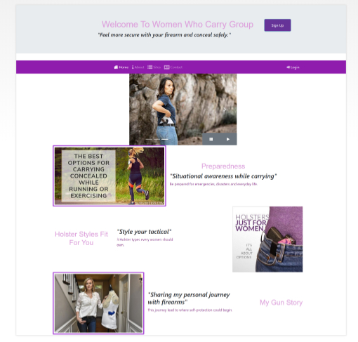

**3. Conclusions**

* Discuss what you personally learned from your project.
* Discuss the best features and the shortcomings of the project: Best features were seeing my ideas visually on a webpage. The shortcomings were from the original coding which did not run properly as I kept coding.
* Discuss any choices that you might have made differently, in hindsight after completing the project: I would like to work on the style of the webpage. I strongly feel that the webpage could look aesthetically better.